Coach |  | Challenger |  | Creator
 |  |  |  | 
What do I need to share? |  | What can I ask? |  | What CAN I do?
Where am I fearing a loss of control? |  | What future consequences do I fear? |  | What is important that I fear loosing?
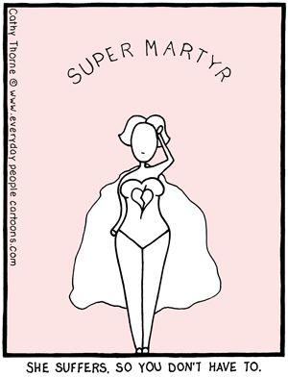 |  | 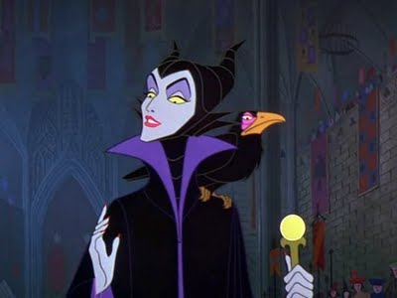 |  | 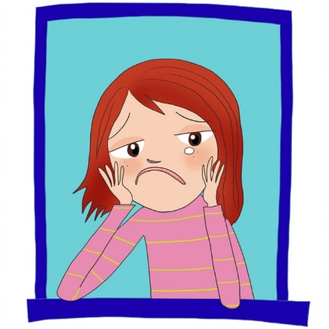
Martyr |  | Villain |  | Victim

Fear of Loss |  | Fear of future consequences |  | Fear of losing control
Victim |  | Villain |  | Martyr
Creator |  | Challenger |  | Coach
What CAN I do? |  | What can I ask? |  | What do I need to share?

